Chemistry 115 Name
Dr. Cary Willard
Exam 1B February 22, 2010

 | Points Earned | Points Possible
Part 1  multiple choice |  | 30
Part 2  nomenclature |  | 10
Page 3 |  | 10
Page 4 |  | 20
Page 5 |  | 18
Page 6 |  | 12
Total |  | 100

Note: All work must be shown to receive credit. On calculation problems show answer with the correct number of significant figures using scientific notation if necessary.

Useful data:

$$K=℃+ 273.16$$
$$℉=\left(℃×1.8\right)+ 32$$
$$℃=\left(℉-32\right)/1.8$$

Part 1 – Multiple Choice (30 points)

- Why study chemistry?
  - To help inform us about our world
  - To be better able to make informed decisions
  - To better understand the properties of matter
  - To help us learn a technique for identifying and solving problems
  - All the above

- Which element is not reactive?
  - Hydrogen
  - Oxygen
  - Helium
  - Iron
  - Aluminum

- One meter is equal to

  - 0.001mm
  - 0.01cm
  - 100mm
  - 1000cm
  - 100 cm

- How many significant digits are in the number 540.2400?

  - 4
  - 5
  - 6
  - 7
  - Can not be determined

- A sample of an unknown substance was tested in a laboratory. The sample could not be decomposed by chemical or physical means. Based on these results the laboratory reported that the sample was most likely a(n)

  - Compound
  - Element
  - Solution
  - Mixture
  - Atom

- Which is not a physical property of water?
  - Water reacts with sodium metal to produce sodium hydroxide and hydrogen.
  - Water is colorless.
  - The freezing point of water is 0º Celsius.
  - The density of water at 4º C is 1.00g/mL.
  - Ice is not as hard as diamond.

- Which has both a definite shape and a definite volume?
  - solid
  - vapor
  - gas
  - liquid
  - plasma

- When expressed in proper scientific notation the number 0.000095532 is

  - 9.5532 X 10⁵
  - 9.5532 X 10^{—5}
  - 9.56 X 10⁻⁵
  - 955 X 10⁻⁷
  - 9.55 X 10⁵

- The elements on the periodic table are placed in order of increasing

  - Density
  - Boiling point
  - Atomic mass
  - Atomic number
  - Atomic size

- How many different elements are present in the compound NH₄NO₃?

  - 9
  - 5
  - 4
  - 3
  - 2

- Which of the following formulas contains the fewest oxygen atoms?

  - Ba(ClO₃)₂
  - Na₂CO₃
  - K₂Cr₂O₇
  - Ca(MnO₄)₂
  - Fe(NO₂)₂

- Which is a cation?

  - Fe⁺²
  - Cl⁻¹
  - H₂
  - Fe
  - Cl₂

- Which cannot be broken down chemically or physically into a simpler substance?

  - Sugar
  - Salt
  - Seawater
  - Copper
  - Lasagna

- Which of the following is a correctly written chemical symbol for an element on the periodic chart?

  - SN
  - Fl
  - titanium
  - ti
  - Sn

- 3.17g of sodium combines with chlorine to form 8.00g of sodium chloride. What is the mass of chlorine in this sample of sodium chloride?

  - 3.17g
  - 4.83g
  - 8.00g
  - 11.17g
  - 6.34g

Part 2 – Nomenclature (10 points)

Fill in the following chart with the correct name or formula for the following elements and compounds.

Compound / Element / Ion Name | Formula / Elemental / Ion Symbol
magnesium
iron(II) ion
 | P
 | O⁻²
Potassium sulfide
Cuprous oxide
Dinitrogen tetroxide
 | CdF₂
 | Cr₂O₃
 | XeF₆

Part 3 – Problems and Questions (60 points)

- (6 points) Evaluate each of the following expressions. State the answer to the proper number of significant figures. (Be sure to round properly!)

  - $53.041+16.5+1901.22=\boxed{\begin{aligned} \\ \\ \end{aligned}}$

  - $\frac{\left(0.00966\right)(15.76)}{21.588}=\boxed{\begin{aligned} \\ \\ \end{aligned}}$

- (4 points) The ruler below is calibrated to measure centimeters. How long is the line in cm?

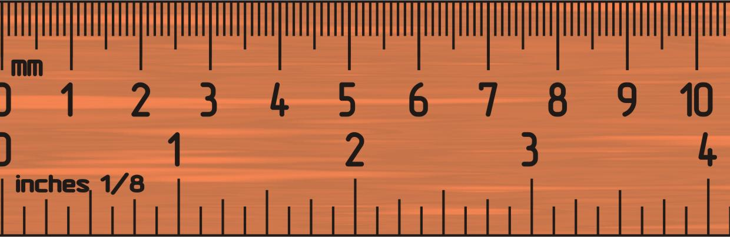
- (6 points) Round the following numbers to 3 significant figures

  - 8.49632 nm

  - 83.4751 kg

  - 3.8528 x 10⁻⁴ mL

- (6 points) Complete the following metric conversions using dimensional analysis. No credit will be given without work complete with units. Give answer to the correct number of significant figures.
  - 8.46 mg to g

  - 96.3 cm to km

- (8 points) Complete the following American / metric conversions using dimensional analysis. Give answer to the correct number of significant figures (If you have forgotten a conversion factors for g to lb or cm to in, make up a number and show the correct set-up for partial credit.)

  - 8.66 kg to lb

  - 4.22 x 10⁻⁶ miles to nm (5280 ft = 1 mile, 1 m = 10⁹ nm)

- (4 points) What is the difference between a homogeneous mixture and a heterogeneous mixture?

- (4 points) The mass of fuel in an airplane must be carefully accounted for before takeoff. If a 747 contains 166,000 L of fuel, what is the mass of the fuel in kilograms? The density of the fuel is 0.768 g/mL.

- (6 points) Iron has a density of 7.87 g/mL. If 62.4 g of iron is added to 75.0 mL of water in a graduated cylinder, to what volume reading will the water level in the cylinder rise?

What is the volume of the iron? (Hint: Do this part 1st)

- (4 points) What is the difference between a hypothesis and a theory?

- (4 points) A solution of 18.27 g sample of sugar syrup is heated until the water has boiled off and 9.42 g of sugar remain. What percent sugar is found in the syrup?

- (4 points) A sample of bronze is 35.9% copper by mass. Find the mass of bronze that contains 80.0 g of copper.

- (4 points) The warmest temperature ever measured in the United States was 134ºF on July 10, 1913, in Death Valley, California. Convert that temperature to degrees Celsius and Kelvin.

Extra credit (3 pts)
Why are coastal geographic regions normally cooler in the summer than inland geographic regions? (Be sure to use concepts of chemistry to answer this question.)

